English Grammar – Past, Present and Changing Habits
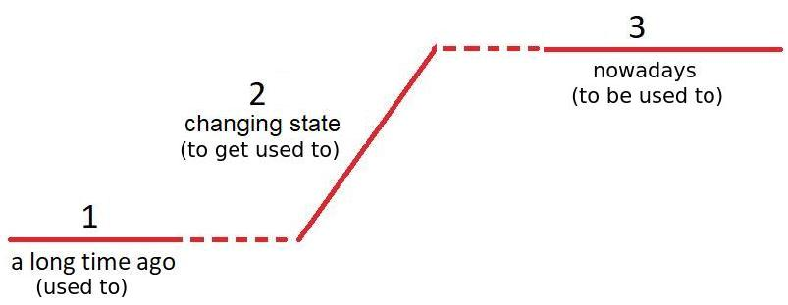

1. Past habit – “used to” + bare infinitive

When I was young, I used to play football with my dad.

When I was at university, I used to smoke a lot.

A: Did you use to smoke? B: No, I didn’t.

I didn’t use to drink wine, but now I love it!

This is a good example of how the word used to be used. (passive voice)

Note: “used to” usually means “costumava” but there are some exceptions:
I used to live in Rio. Eu morava no Rio. Eu costumava morar no Rio.
She used to be skinny. Ela era magra. Ela costumava ser magra.
I didn’t use to like coffee. Eu não gostava de café. Eu não costumava gostar de café.

3. Present habit (or state) – “to be used to” + noun/gerund

I live in Brazil, so I am used to Brazilian food.

I live in Brazil, so I am used to eating Brazilian food.

I live next to a school, so I am used to a lot of noise!

I live next to a school, so I am used to hearing a lot of noise!

Note: A synonymous phrase is “to be accustomed to” (formal English)

Example: I am used to speaking English.

(or) I am accustomed to speaking English.

2. Changing state (transition) – “to get used to” + noun/gerund (= “to adapt”)

I used to live in a house, but I quickly got used to an apartment.

I used to live in a house, but I quickly got used to living in an apartment.

I’m living in England, so I need to get used to English roads.

I’m living in England, so I need to get used to driving on English roads.

It’s impossible! I can’t get used to driving on English roads!

It’s so hot in Fortaleza, but I’m getting used to the hot weather.

It’s so hot in Fortaleza, but I’m getting used to living here.

It’s so hot in Fortaleza, but I will get used to living here.

Here is a complete example:
When I started work, I used to drink normal coffee. (past habit)
Then I decided to switch to decaffeinated coffee.
I took a long time to get used to drinking decaffeinated coffee. (transition)
Now, I am used to drinking decaffeinated coffee. (present habit)

Suggested videos:
https://www.youtube.com/watch?v=BGVl_nTJY7A (10 mins)
or: https://www.youtube.com/watch?v=53gXPS_ohZs (12 mins)

Exercise. Complete the sentences using “used to”, “get used to” or “be used to”, and the given verbs, conjugating appropriately:

1. Before, I thought that Maria was irritating, but now I ____________________ with her. (work)
2. When we were at university, we ________________________ wine every night! (drink)
3. I can understand Monique because I _________________________ French. (speak)
4. At first, I didn't like my job, but now I _____________________ it.

5. It ___________________ attractive to smoke (be), but nowadays, many people find it offensive.

6. It often takes a long time _____________________ a new job.

7. Running is hard for me because I __________________________ exercise. (not / do)

8. We've lived here for a week and slowly, we _____________________ the neighborhood.

9. a. We _____________________ together. (work) (past habit)
b. We _____________________ together. (work) (present habit)

10. I took a long time _________________________________ married. (be)

